Fixing the VirtualBox Network Adapter Error

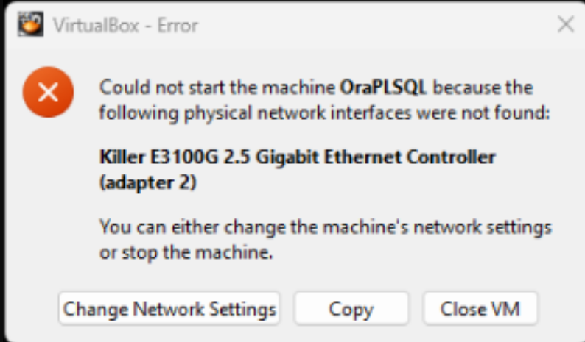

What’s the problem?
When you import a virtual machine (VM) into VirtualBox, it may fail to start with a network error.
→ This happens because the VM was created on another computer → That computer had a network card your system does not have → VirtualBox is trying to use hardware that doesn’t exist on your machine

The Quick Fix (Most Users)
If you see an error popup:
→ Click Change Network Settings → Follow the steps below → Start the VM again

Step-by-Step Checklist (Recommended)

Step 1: Open the VM settings
→ Open VirtualBox Manager → Select the virtual machine → Click Settings

Step 2: Go to Network settings
→ Click Network in the left menu → Look for Adapter 2 (this usually causes the issue)

Step 3: Choose ONE fix below

Option 1: Change the network type (Best option)
→ Keep Enable Network Adapter checked → Change Attached to → NAT
✅ NAT works on almost all computers ✅ No extra setup required

Option 2: Disable the adapter (Easiest)
→ Uncheck Enable Network Adapter
✅ VM will start without errors ⚠️ VM will have no internet access

Option 3: Change the adapter type (Advanced but safe)
→ Click Advanced → Change Adapter Type → Select Intel PRO/1000
✅ Very compatible across systems

Step 4: Save and start
→ Click OK → Start the virtual machine
🎉 The VM should now boot without errors

Summary
→ The VM is looking for a network card that doesn’t exist → Set the network to NAT or disable the adapter → Start the VM again

